<https://blog.csdn.net/qq_29736627/article/details/130893020>

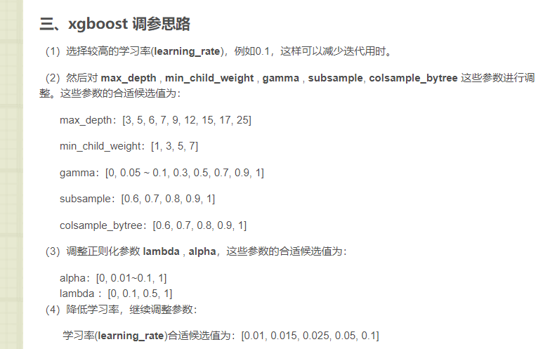

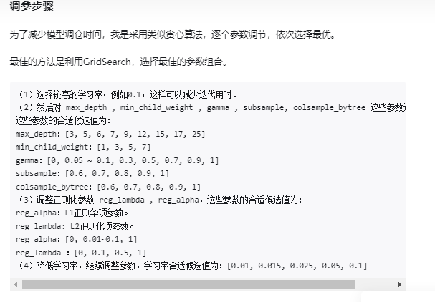

1-20

#{'max_depth': 18}---0.9865271596936263

param_grid={

'max_depth':np.arange(1,21,1)

}

1-20

#{'min_child_weight': 5}---0.9873603166097424

param_grid={

'min_child_weight':np.arange(1,21,1)

}

0-1

#{'gamma': 0.0}---0.9873603166097424--默认

param_grid={

'gamma':np.linspace(0,1,21)

}

0-1  
#{'subsample': 0.6000000000000001}----0.9894673801009064

param_grid={

'subsample':np.linspace(0,1,21)

}

0-1

#{'colsample_bytree': 0.25}-----0.9930519695855529

param_grid={

'colsample_bytree':np.linspace(0,1,21)

}

0-1

#{'alpha': 0.0}---0.9930519695855529

param_grid={

'alpha':np.linspace(0,1,21)

}

0-1

#{'reg_lambda': 0.1}---0.9933975300481566

param_grid={

'reg_lambda':np.linspace(0,1,21)

}

0-1

#{'learning_rate': 0.1}---0.9933975300481566

param_grid={

'learning_rate':np.linspace(0,1,21)

}